**SONAR QUBE**

**Maven: Build Tool (Compile+ Test+ Package)**

**Nexus: Artifact Repository Server ( Build + Share libs)**

**Git HUB: Version Control S/W , to Store Project Source Code.**

**Tomcat: Webserver , to run the web application.**

**Alternate for sonar Qube, Sonar link is available.**

**SonarQube:**

* **It is used for Code Quality Checking**
* **It is free and opensource s/w developed by using JAVA**
* **It is used to perform code review and identify mistakes in the code**
* **SonarQube supports 20+ Programming Language**

**Like ( java, Python, Dotnet)**

* **Sonar Qube will identify below uses in the code.**
  + 1. **Bugs ->Errors which are available in the application(program Mistakes)**
    2. **Vulnerabilities ->if you have vulnerabilities , hackers can attack on an application, Security issues where hacker can attack the application**
    3. **Code Smells ->Some minor issues Recommended to fix**
    4. **Code Coverage (80 %) -> How much unit test done on the project . As per industries standard minimum 80% should be there, then only company has accepted the code.**
    5. **Duplicate Code. ->Repeated code . If Multiple developers write same code in the project .**

**Above mentioned issued should not be available in the project .**

* **As a devops engineer we are responsible to generate code Review report and send it to development team**
* **Development Team is responsible to fix sonar issues available in the code.**

**Note: If project having sonar issues , Client will not accept the project.**

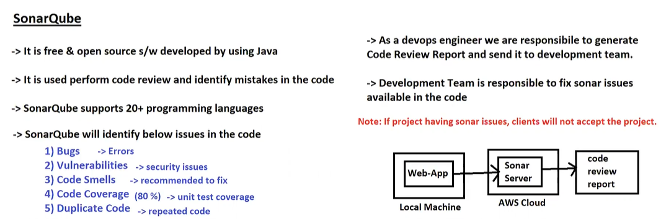

* **Sonar Community addition**
* **Sonar Commercial addition**

**Each addition is available**

[**https://www.sonarsource.com/products/sonarqube/**](https://www.sonarsource.com/products/sonarqube/)

**Demo:**

**Sonar Qube:**

* **Sonar Qube is Continuous code Quality checking Tool**
* **We can do code Review using Sonar Qube Tool**

**What is different between code Review and Code Coverage:**

**Code Coverage: How many lines of source code is tested by unit test cases**

**Note: Industry Standard Code Coverage is 80%**

**Code Review: Checking Code Conventions / Standards**

**Sonar Qube is an open-source , software quality management tool**

**It will Continuously analyze and measure quality of the source code**

**It will generate code review report in html format/ PDF format**

**It is a web-based tools and supports 29 Programming Languages**

**It will support multi-OS platform**

**It will support multi database (MYSQL, Oracle, SQL Server , PostgreSQL)**

**It supports multiple Browser**

**Sonar Qube identify below categories of issues**

1. **Duplicate code**
2. **Coding standards**
3. **Unit test**
4. **Code Coverage**
5. **Complex Code**
6. **Commented Code**
7. **Potential Bugs**

**Initially Sonar Qube was developed only for java Project**

**Today Sonar Qube is supported for 29 Languages**

**Environment Setup**

**++++++++++++++++++**

**-> Java is the pre-requisite software**

**7.6 --> Java 1.8v**

**7.8 - 8.x --> Java 11v**

**Note: We can check this compatibility in official sonar website**

**Hardware Requirements**

**+++++++++++++++++++++**

**Minimum RAM : 2 GB**

**t2.medium ---> 4 GB RAM**

**-> Create EC2 instance with 4 GB RAM (t2.medium)**

**-> Connect with EC2 instance using MobaXterm**

**-> check space (free -h)**

[**https://www.sonarsource.com/products/sonarqube/downloads/**](https://www.sonarsource.com/products/sonarqube/downloads/)

**Companies mostly will use Enterprise Edition**

**sudo yum update -y (updating the package)**

**$ sudo su**

**$ cd /opt**

**$ sudo yum install java-1.8.0-amazon-corretto**

**$ java -version**

**$ wget https://binaries.sonarsource.com/Distribution/sonarqube/sonarqube-7.8.zip**

**$ unzip sonarqube-7.8.zip**

**Note: SonarQube server will not run with root user**

**Create new user in ec2 instance**

**$ useradd sonar**

**$ visudo**

**-> Configure sonar user without pwd in suderos file**

**sonar ALL=(ALL) NOPASSWD: ALL**

**-> Change ownership for sonar folder**

**$ chown -R sonar:sonar /opt/sonarqube-7.8/**

**$ chmod -R 775 /opt/sonarqube-7.8**

**$ su - sonar**

**-> Goto bin directory then goto linux directory and run sonar server**

**$ cd /opt/sonarqube-7.8/bin/linux-x86-64**

**$ sh sonar.sh start**

**-> Check sonar server status**

**$ sh sonar.sh status**

**Note: Sonar Server runs on 9000 port number by default**

**Note: We can change default port of sonar server ( conf/sonar.properties)**

**Ex: sonar.web.port=6000**

**-> Enable port number in EC2 VM - Security Group**

**-> Access Sonar Server in Browser**

**URL : http://EC2-VM-IP:9000/**

**-> Default Credentials of Sonar User is admin & admin**

**-> After login, we can go to Security and we can enable Force Authentication.**

**Note: Once your work got completed then stop your EC2 instance because we have t2.medium so bill be generated.**

**$ sh sonar.sh status**

**Note: If sonar not started, then go to log file and see**

**$ sudo rum -rf /opt/sonar-folder/temp/**

**$ cd ../bin/**

**$ sh sonar.sh start**

**$ sh sonar.sh status**

**-> Access sonar server in browser and login into that**

**\*\*\*\*\*\*\*\*\*\*\*\*\*\*\*\*\*\*\*\*\*\*\*\*\*\*\*\*\*\*\*\*\*\*\*\*\*\*\*\*\*\*\*\*\*\*\*\*\*\*\*\*\*\*\*\*\*\*\*\*\*\*\*\*\*\*\*\*\*\*\*\*\*\*\*\*\***

**Go to maven project and create the maven project on your laptop and configure the Sonar username password in POM.XML**

**$ sh sonar.sh status**

**Note: If sonar not started, then go to log file and see**

**$ sudo rum -rf /opt/sonar-folder/temp/**

**$ cd ../bin/**

**$ sh sonar.sh start**

**$ sh sonar.sh status**

**-> Access sonar server in browser and login into that**

**+++++++++++++++++++++++++++++++++++++++++++**

**Integrate Sonar server with Java Maven App**

**+++++++++++++++++++++++++++++++++++++++++++**

**-> Clone git repository : https://github.com/ashokitschool/SB-REST-H2-DB-APP**

**-> Configure Sonar Properties under <properties/> tag in "pom.xml"**

**<properties>**

**<sonar.host.url>http://13.113.31.29:9000/</sonar.host.url>**

**<sonar.login>admin</sonar.login>**

**<sonar.password>admin</sonar.password>**

**</properties>**

**-> Go to project pom.xml file location and execute below goal**

**$ mvn sonar:sonar**

**-> After build success, go to sonar dashboard and verify that**

**Note: Instead of username and pwd we can configure sonar token in pom.xml**

**++++++++++++++++++++++++++**

**Working with Sonar Token**

**+++++++++++++++++++++++++++**

**-> Goto Sonar -> Login -> Click on profile -> My Account -> Security -> Generate Token**

**-> Copy the token and configure that token in pom.xml file like below**

**<sonar.host.url>http://44.202.35.246:9000/</sonar.host.url>**

**<sonar.login>a9e272c0cb673023bb36dfef42c0442942d0a9c2</sonar.login>**

**-> Then build the project using "mvn sonar:sonar" goal**

**#################**

**Quality Profile**

**#################**

**-> For each programming language sonar Qube provided one quality profile with set of rules**

**-> Quality Profile means set of rules to perform code review**

**-> We can create our own quality profile based on project requirement**

**-> Create One Quality Profile**

**- Name : SBI_Project**

**- Language: Java**

**- Parent : None**

**Note: We can make our quality profile as default one then it will be applicable for all the projects which gets reviewed under this sonar server.**

**Note: If we have any common ruleset for all projects then we can create one quality profile and we can use that as parent quality profile for other projects.**

**-> We can configure quality profile to specific project**

**- click on project name**

**- Go to administration**

**- Click on quality profile**

**- Select profile required**

**################**

**Quality Gate**

**################**

**-> Quality Gate represents set of metrics to identify project quality is Passed or Failed**

**-> Every Project Quality Gate should be passed**

**-> In Sonar We have default Quality Gate**

**-> If required, we can create our own Quality Gate also**

**Note: If project quality gate is failed then we should not accept that code for deployment.**

**--------------------------------------------------------------------------------------------------------------------------------------**

**===========**

**conclusion**

**===========**

**-> If project is having Sonar issues, then development team is responsible to fix those issues**

**-> As a DevOps engineer, we will perform Code Review and we will send Code Review report to Development team (we will send sonar server URL to development team)**

**c56eb951807dea2f31e74ea47a205f573d6b2273**

**telugu tech it factory**